**Highland Terrace Fall Art class**

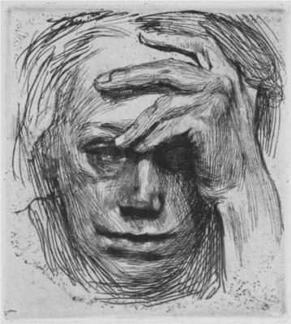

**When:** Tuesdays 3:30-5pm, Oct. 17, Oct. 24, Nov. 7, Nov. 14, Nov. 28, Dec. 5, Dec. 12

**Where:** Classes will begin in the Library at 3:30, and move to Cafeteria (this is where you pick up your student)

**Who: You!** Lessons are geared towards 3-6th graders

**How much:** $100 for 7 sessions, $= delivered to main office with this form. Cash/check (**made out to Crystal Cissell-Anderson**).

**What can I expect:** Each week we will study and talk about different artists related to the medium (materials) being used. We will use these artists to get ideas, not copy. This class will focus on the technical skills of drawing from observation (using drawings & photos for reference), adding value to create 3-dimensional form, and using Prismacolor Pencils to blend and shade. **The Teacher:** Crystal Cissell-Anderson has a BA of Fine Arts in drawing and painting. She currently teaches at Loyal Heights Elementary. **Teaching Philosophy:** I believe strongly in the unique skills and understanding that the visual arts teach. Skills such as: understanding that problems may have more than one answer, and that answer, is not defined by right or wrong.

**Registration Form**- return to main office with $- **due by Sept. 27th.** **A PTA Sponsored Enrichment Program**

|  |
| --- |
| Student Name He/She Grade: Teacher: |
| Email Address(es) |
| Medical Concerns (Allergies) |
| Parent/Guardian #1: **Emergency Contact Name:** Cell#: Relationship to child: |
| Parent/Guardian #2 Cell#: Relationship to child: |
| **Specify who is authorized to pick up the sudent:** |

**Volunteers:** Each class needs 1-2 parent volunteers. Parents willing to volunteer the entire 6 weeks will pay $0 total. We are not authorized to have younger siblings come hang out with parent volunteers, who are helping in the classroom.

|  |
| --- |
| **I can volunteer on the following day(s)- Circle- Oct. 17, Oct. 24, Nov. 7, Nov. 14, Nov. 28, Dec. 5, Dec. 12** |

**Limited scholarships** may be available. To apply contact the Family Advocate, Sherri Dobb, at 206-393-4346

**Refund policy:** Money will be refunded if you need to cancel by 10/2/17.

**Absence policy:** If a student is absent a class session no money will be refunded for the class missed. If a student has an illness that prevents them from attending for multiple classes please contact me, and we will work something out. If I, the instructor, have to cancel a class another class day will be made available on a Tuesday.

**Student’s dismissal:** **Students will be dismissed to the parent/chaperone on my list only.** Any other arrangements need to be made by the parent/chaperone, **prior** to the class that it applies to. Please email me. Students going to Day Care will be dismissed to Day Care. Students need to be picked up promptly after class. We are not authorized to provide childcare for the student after 5pm. If this becomes an issue (and pick up is more than 10 minutes late, twice per session), a student may be dropped from the class without refund.

**Special Accommodations:** Individuals requiring special accommodations to attend or participate in PTA’s meetings or events are requested to contact the coordinator, Crystal Cissell-Anderson at [ccissellanderson@gmail.com](mailto:ccissellanderson@gmail.com) or 206-482-5258, sufficiently in advance to allow for any necessary arrangements.